# Project 1: Live Web Application Security Audit & Hardening

### Objective

To perform a security audit of a live production website (writingbeginner.com), identify vulnerabilities in its network and encryption configuration, and execute a remediation plan to harden the attack surface. This project demonstrates a full "Scan -> Remediate -> Verify" security lifecycle, including professional vendor interaction and root cause analysis of a complex server misconfiguration.

### Tools Used

* **Nmap:** For network discovery and port scanning.
* **Qualys SSL Labs:** For in-depth analysis of TLS/SSL configuration and vulnerabilities.
* **WSL (Ubuntu):** As the Linux environment for running command-line tools.

### Phase 1: Initial Reconnaissance & Findings

The initial phase focused on gathering baseline data to understand the website's current security posture from an external perspective.

Finding 1: Insecure Services Exposed

An Nmap scan (nmap -F writingbeginner.com) was executed to identify open ports on the server. The scan revealed several open ports, with the most critical finding being Port 21/tcp (FTP). FTP is an unencrypted protocol that transmits credentials in cleartext, posing a significant security risk if active user accounts exist.

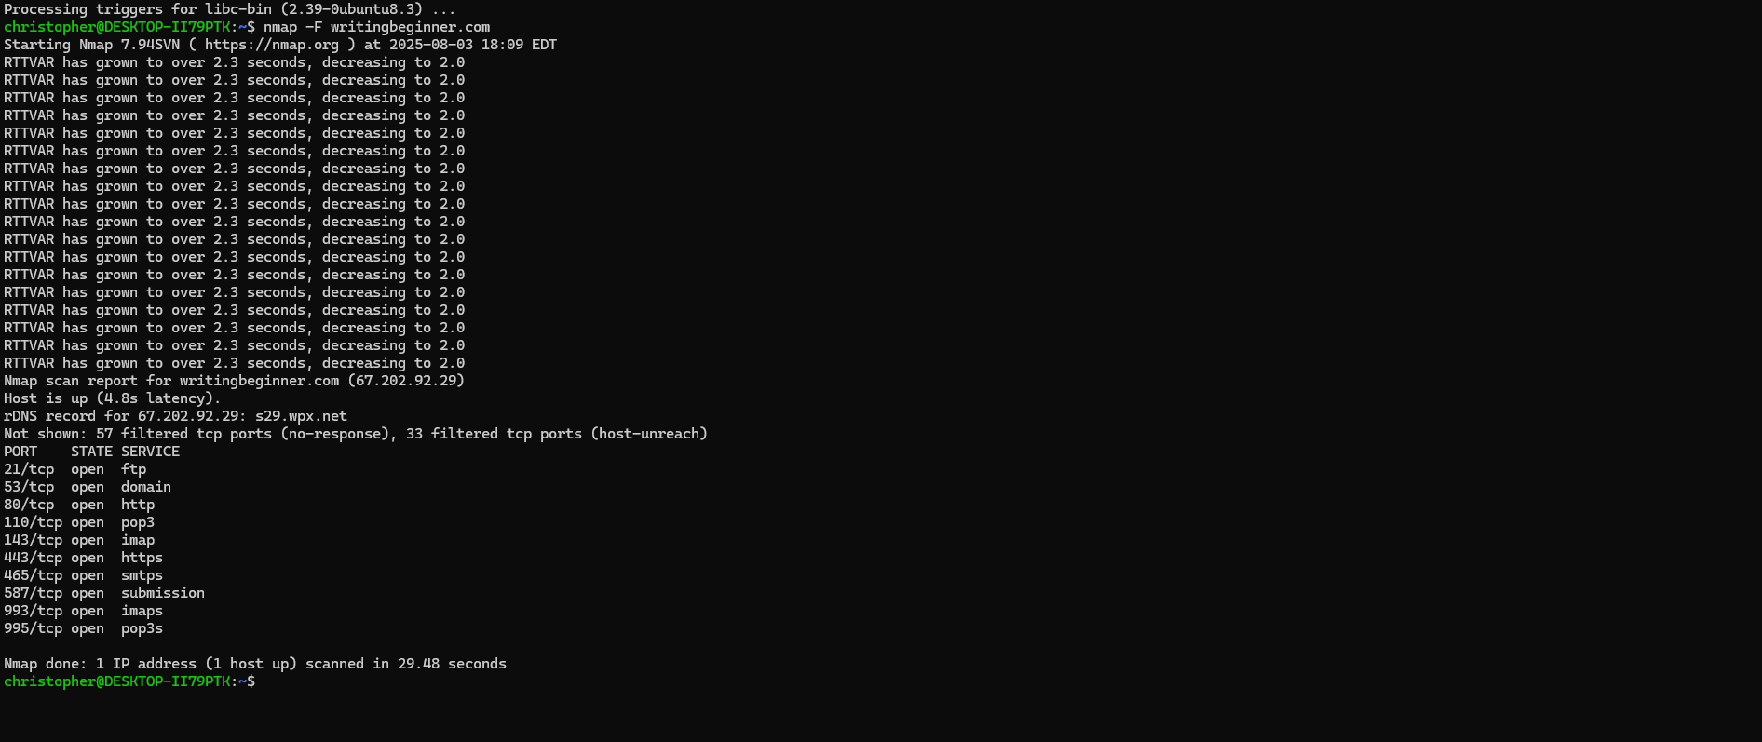

Finding 2: Incomplete Encryption Configuration

A scan using Qualys SSL Labs was performed to assess the strength of the site's TLS/SSL implementation. While the site received a respectable overall grade of 'A', the detailed report identified a key weakness: HTTP Strict Transport Security (HSTS) was not enabled. HSTS is a critical security header that protects against protocol downgrade attacks and cookie hijacking by forcing browsers to use only secure connections.

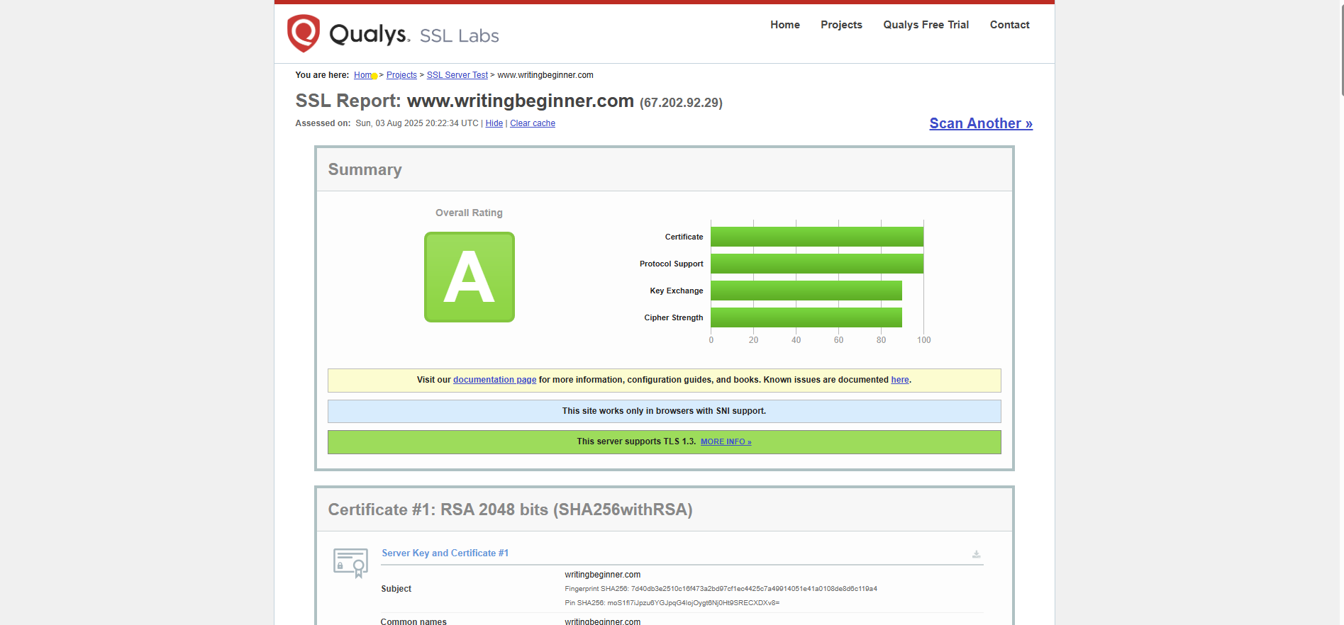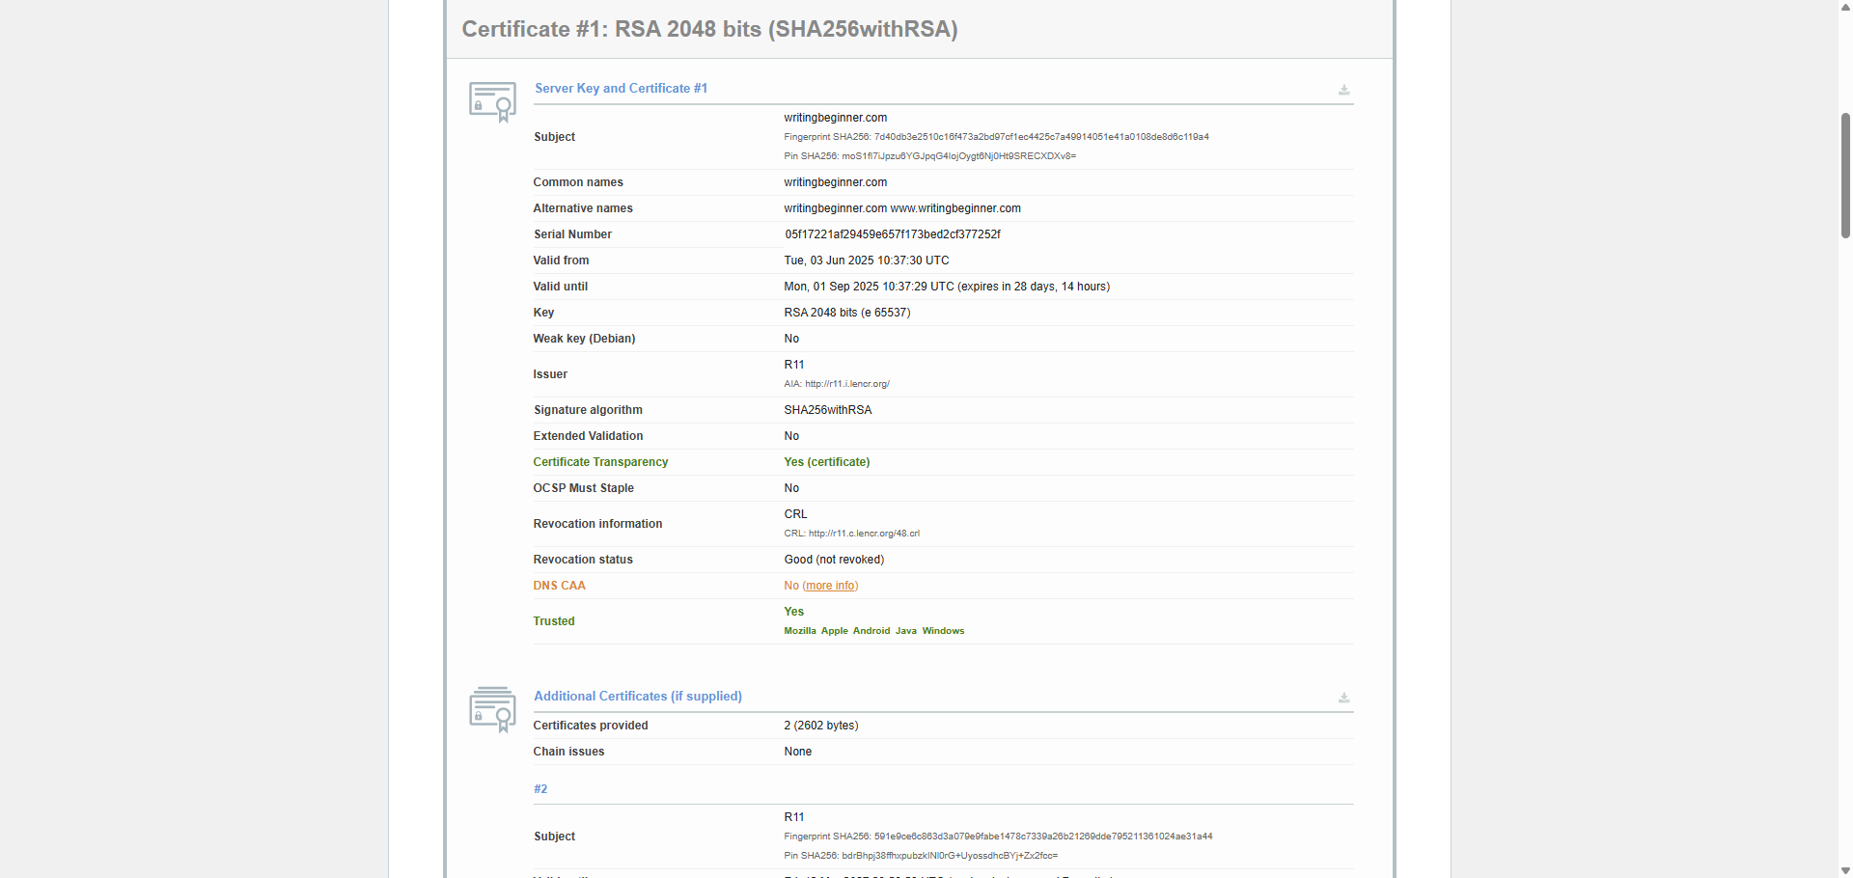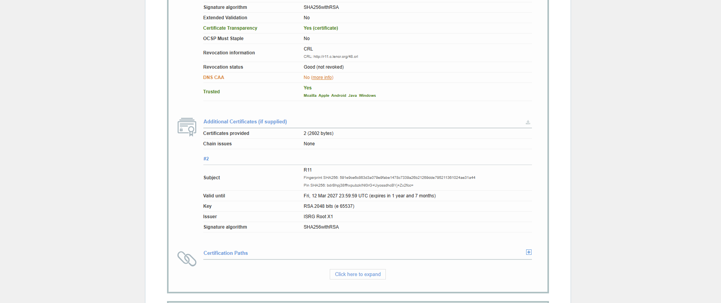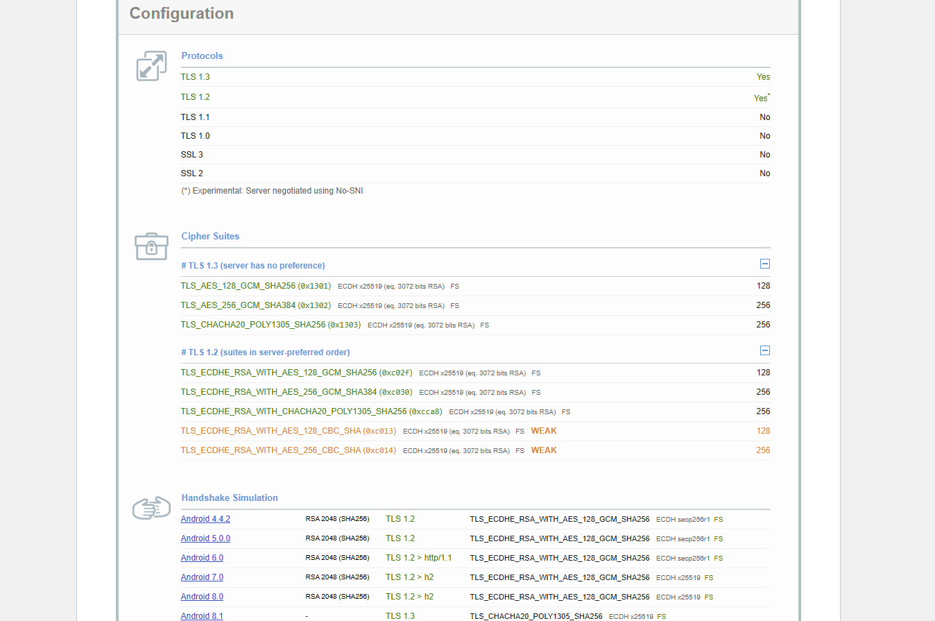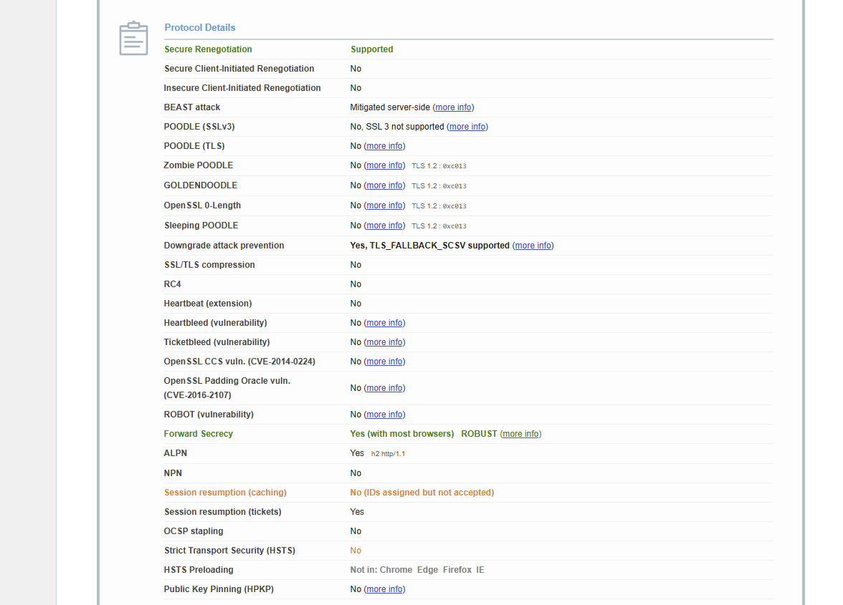

### Phase 2: Mitigation & Vendor Interaction

Based on the initial findings, a remediation plan was developed, requiring interaction with the hosting provider (WPX).

Action on FTP Risk:

I first confirmed within the hosting control panel that no active FTP user accounts existed, which served as an immediate compensating control. I then submitted a support ticket to WPX requesting that port 21 be closed at the firewall level. The agent informed me this was a server-wide setting that could not be changed for a single account. The risk from the open port was therefore formally accepted, with the lack of FTP users being the documented mitigating factor.

Action on HSTS:

I requested that WPX enable HSTS. The support agent initially replied that HSTS was already enabled and provided a screenshot of the site's .htaccess file as evidence, which did contain the HSTS header rule.

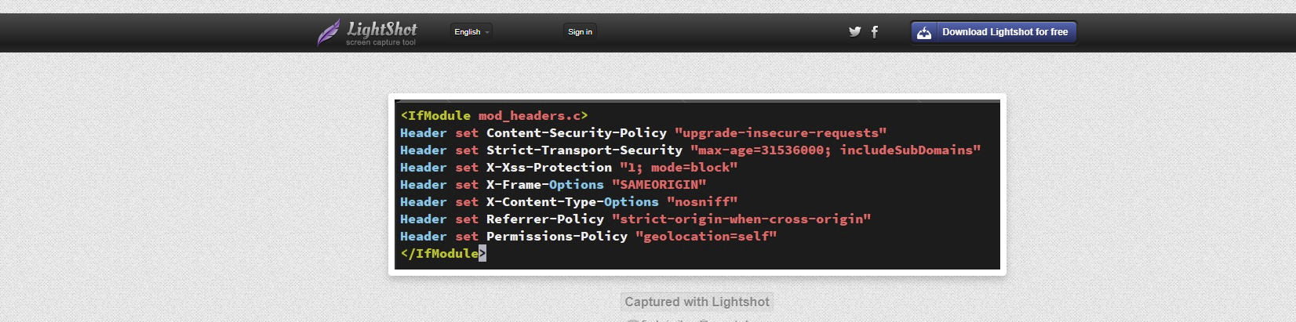

This created a critical discrepancy: the server's configuration file contained the rule, but external scanning tools proved the rule was not being applied in practice. Following a "trust, but verify" methodology, I initiated a second verification scan to gather definitive evidence.

### Phase 3: Verification & Root Cause Analysis

The final phase involved re-running the scans to validate the server's real-world behavior against the agent's claims.

Nmap Verification:

A second nmap scan confirmed the agent's statement: port 21 remained open, validating the decision to accept this as a systemic constraint.

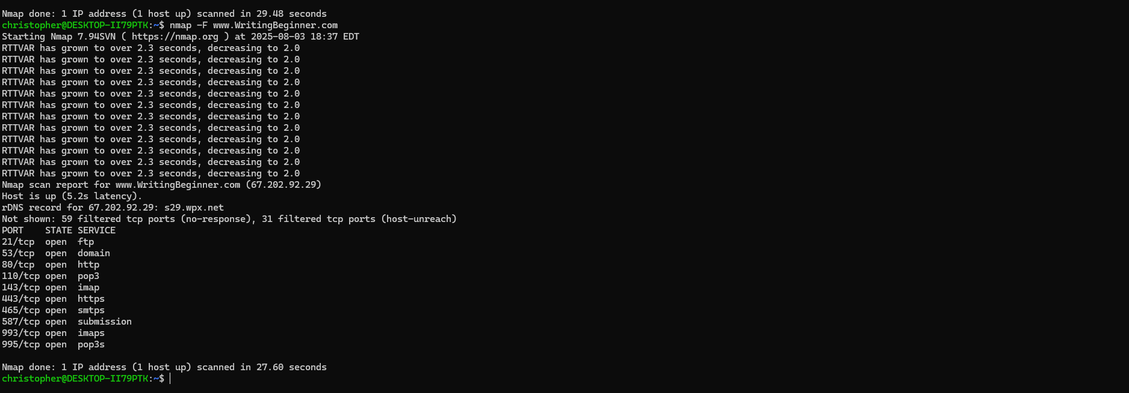

SSL Labs Verification & Root Cause:

The SSL Labs scan was re-run with the cache cleared. The new report proved that HSTS was still not enabled, despite its presence in the .htaccess file.

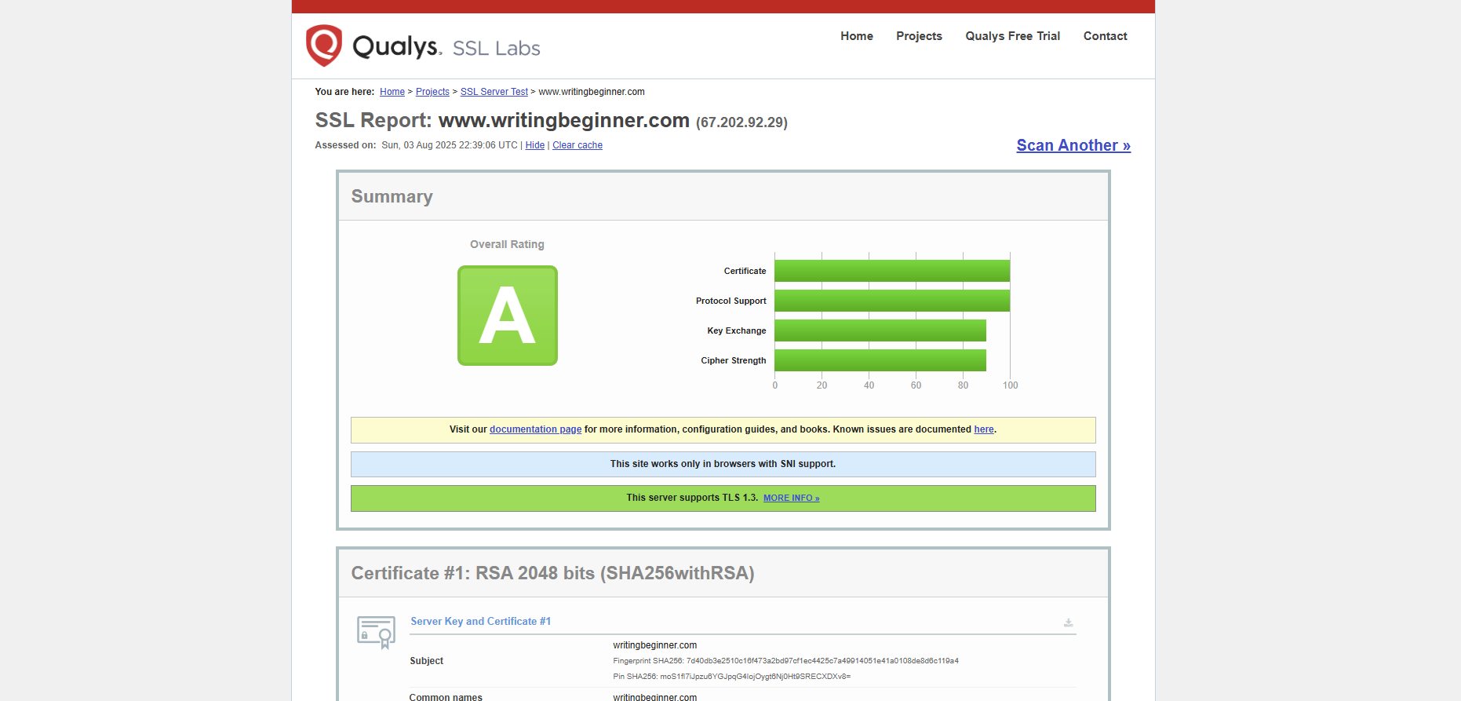

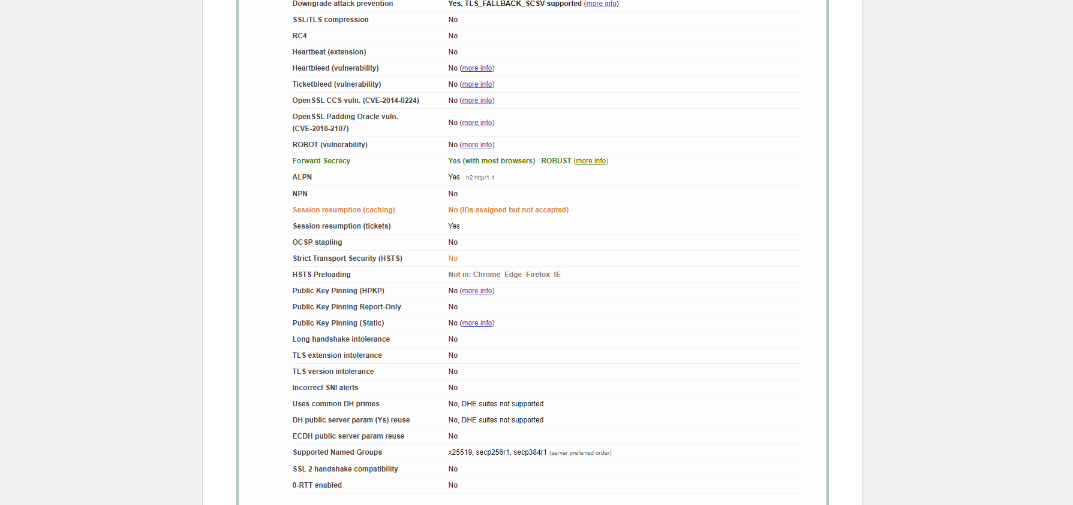

This evidence pointed to a more complex issue: a **server-level misconfiguration**. The .htaccess file, which is used by Apache web servers, was likely being ignored or overridden by a higher-level Nginx reverse proxy server, a common architecture used by managed hosts like WPX for performance. The HSTS rule existed but was never being processed.

I escalated the issue back to the support agent, providing a direct link to the live SSL Labs report as undeniable proof of the discrepancy.

### Conclusion & Skills Demonstrated

This project successfully identified multiple security weaknesses and uncovered a nuanced server misconfiguration that was not immediately apparent even to the hosting provider's support team.

* **Final Outcome:** The risk from the open FTP port was mitigated through a compensating control. A critical misconfiguration preventing the HSTS security header from being applied was identified and escalated to the vendor with verifiable evidence for final resolution.
* **Skills Demonstrated:**
  + **Vulnerability Identification:** Used industry-standard tools to find real-world security weaknesses.
  + **Technical Analysis:** Interpreted scan results and configuration files to understand root causes.
  + **Root Cause Analysis:** Diagnosed a complex issue involving conflicting server technologies (Nginx overriding Apache .htaccess).
  + **Vendor Communication:** Professionally engaged with a third-party vendor to resolve security issues.
  + **Evidence-Based Escalation:** Used data and tool-generated reports to challenge incorrect information and drive toward a resolution.
  + **Risk Management:** Understood and applied the concept of a compensating control when a primary control was not feasible.